Go to sources

Go to Dental apps

Go to Dentrix trojan viewer 6.0

And install the software

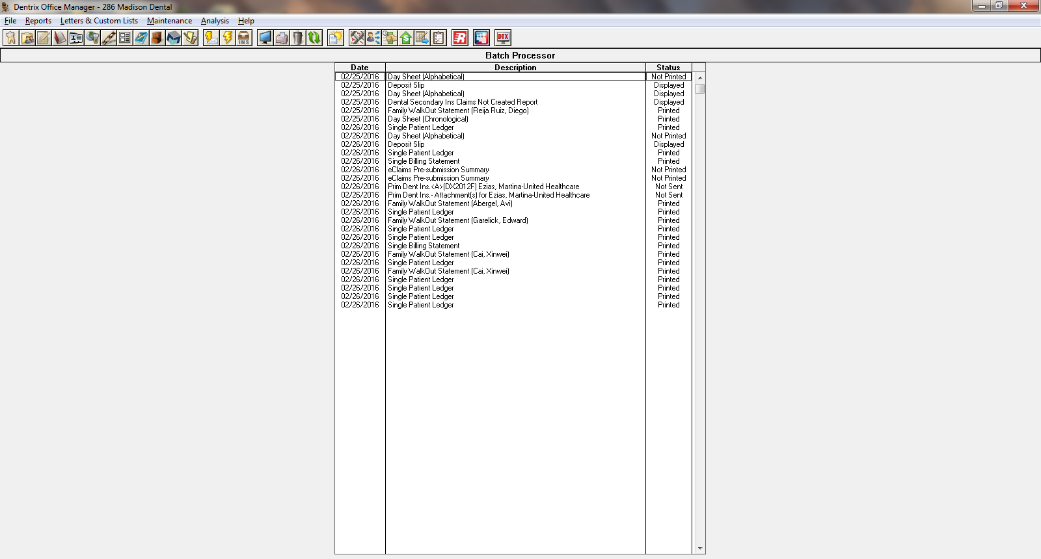

Click on the office manager on Dentrix

Click on Maintenance

Click on Practice Setup

Click on preference (under the Practice Setup)

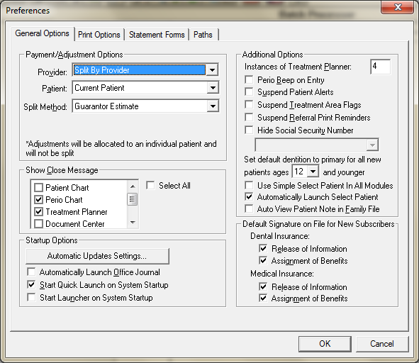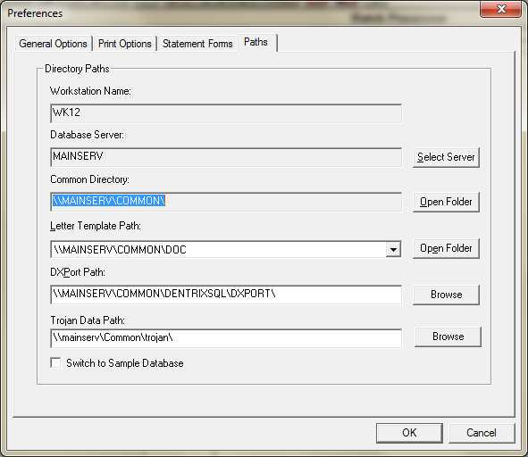

Choose the correct path on the Trojan data path